***INTERNSHIP PROJECT***

**Project Details:**

Project- 1: - Authentication Bypass  
  
1) Take some random websites using Google hacking database and enter into their admin panel using SQL Injections (Manual and using a tool called burp suite)  
  
2) Show some live cameras using Google hacking database.

Project 1: - Authentication Bypass

1. **SQL Injection:**

**Manual: -**

Authentication Bypass by using SQL injection is done on website

http://www.snvmpgcollege.com/alogin.aspx

Hear I have done SQL injection in 2 ways:

* I have use username as uname’-- and fill password box randomly means for ex: 1234, abcd, xys. Uname is username
* In second method I have use the **OR** operator in username and password.

Here are some of snapshot of SQL Injection.

Found the website by using Google Dork (Exploit DB)

**Method 1: -**

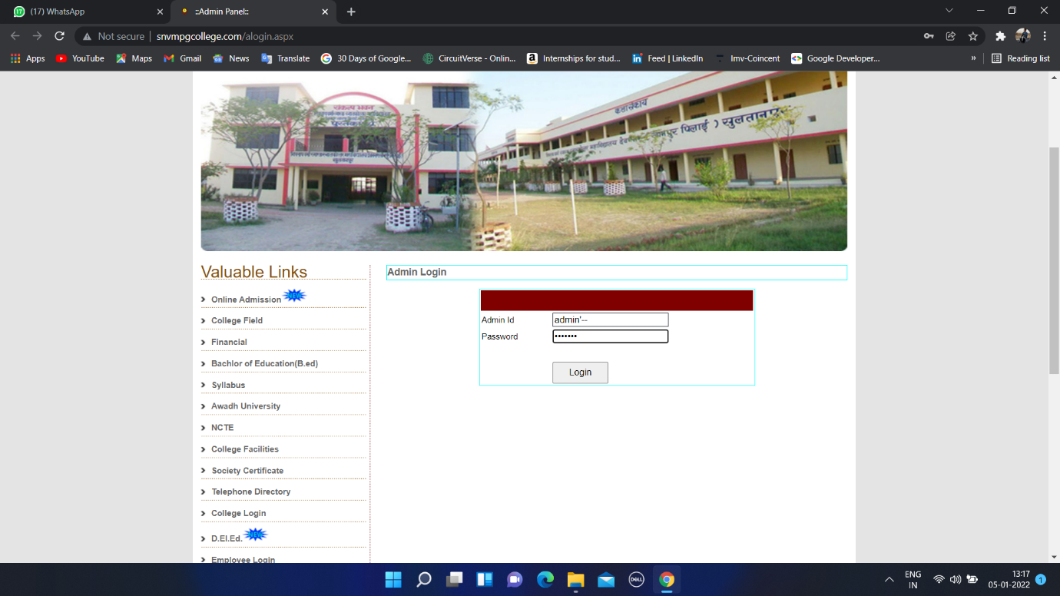

**Here I have used:**

**Admin ID: - admin’--**

**Password: - abcderfs**

* **RESULT:**

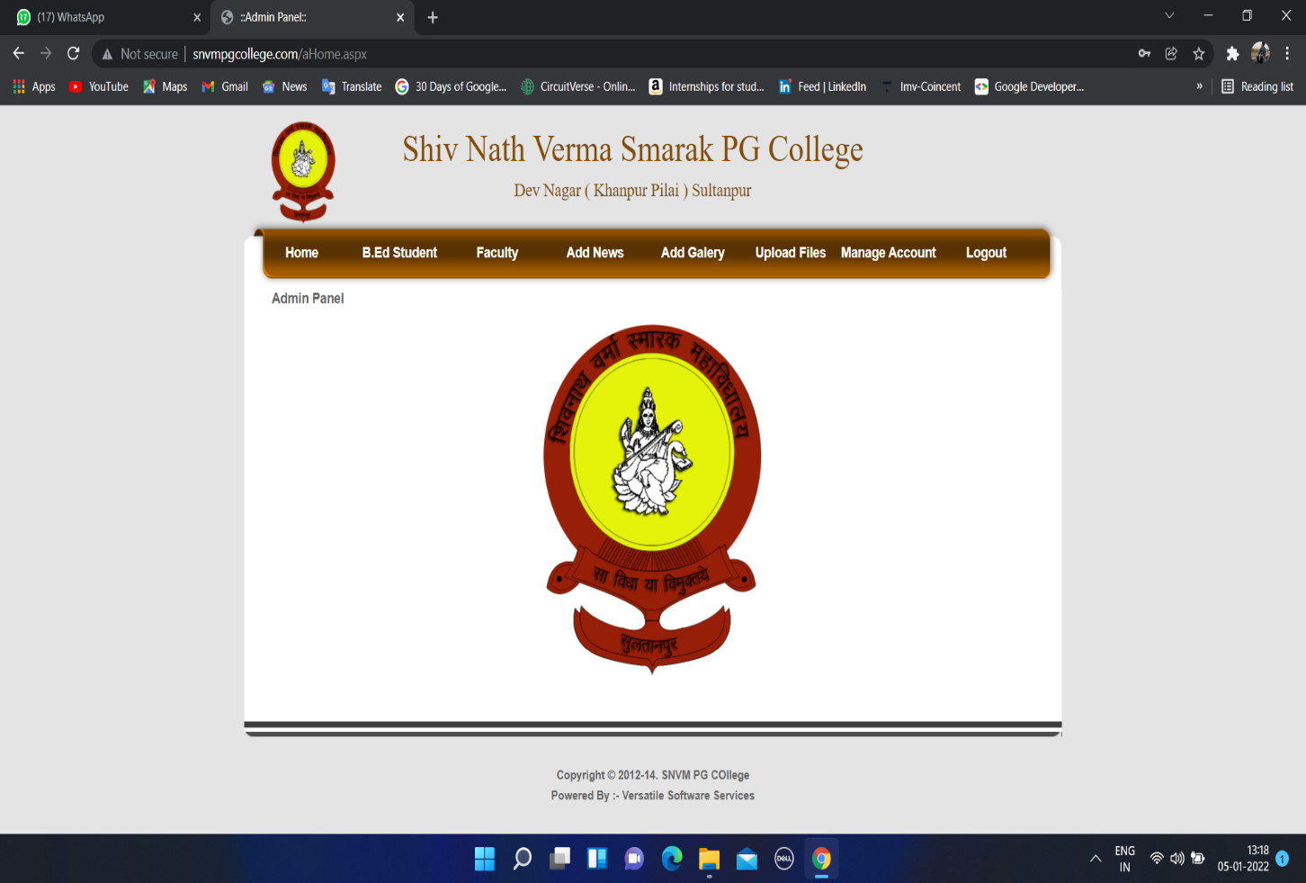

Logout sign show that I have successfully log in to the website. Means SQL Injection is done successfully without knowing the exact username and password.

**Method 2:**

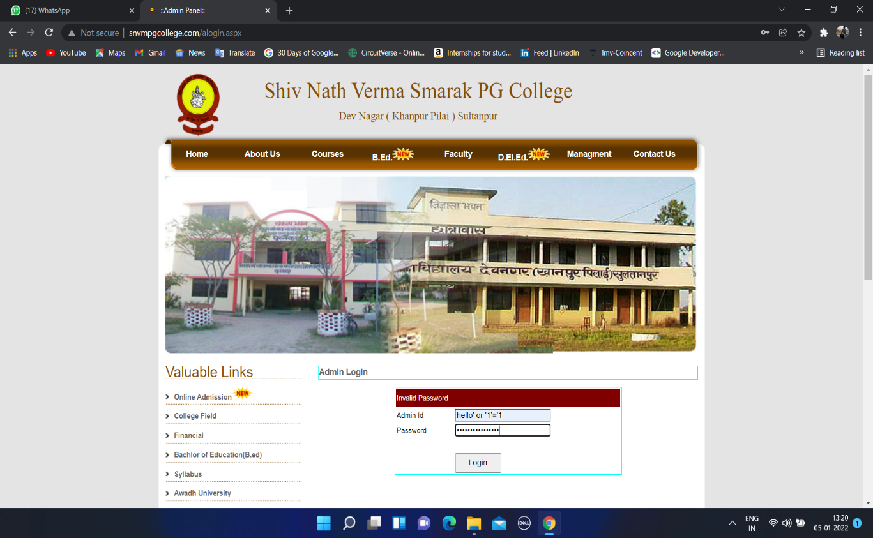

**Here I have used Admin ID: hello’ or ‘1’ = ’1**

**Password: hello’ or ‘1’ = ’1**

* **Result: -**

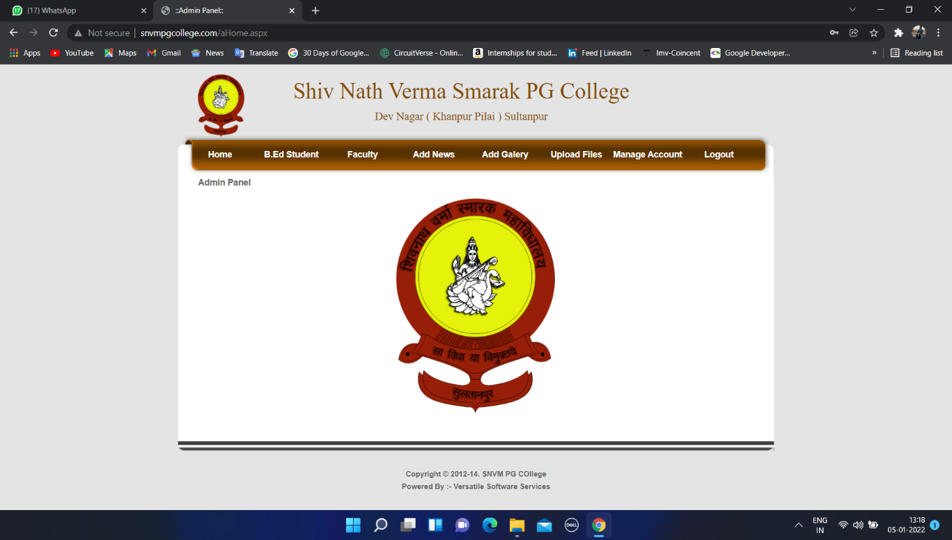

Logout sign show that I have successfully log in to the website. Means SQL Injection is done successfully without knowing the exact username and password.

1. SQL Injection using Burp Suite: **-** Burp suite is tool which is used for SQL Injection. The only main thing to set up is proxy.

Step 1) Firstly, we need to set up the proxy on browser after listening proxy of burp suite.

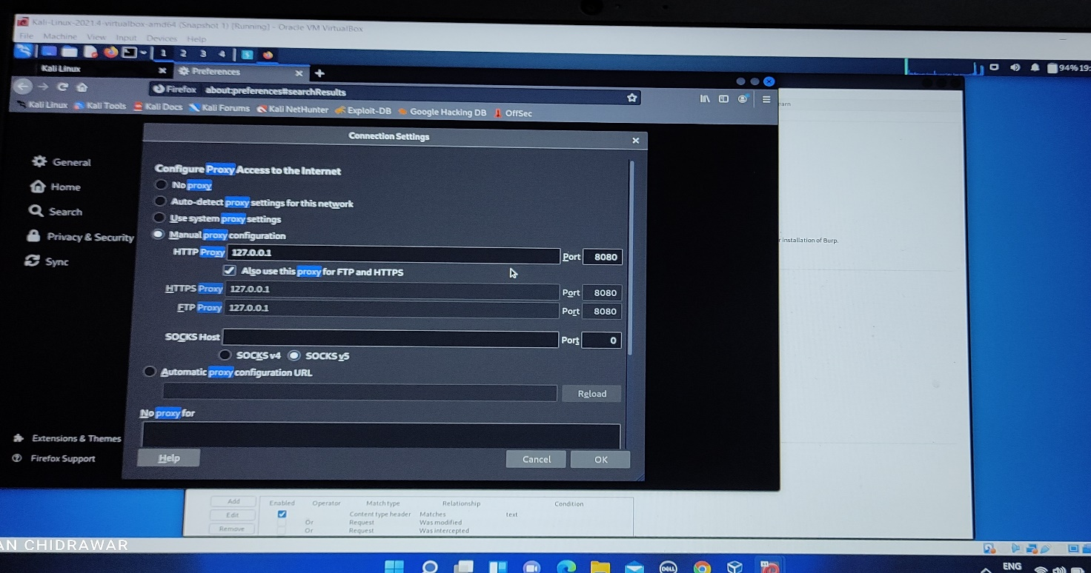

As my burp suite is listening 127.0.0.1 on 8080 port. Here is the setting of proxy on browser.

Step 2- Then open the website on browser, the request will send to the Burp Suite. Then just click on **forward** tab, website get open in browser

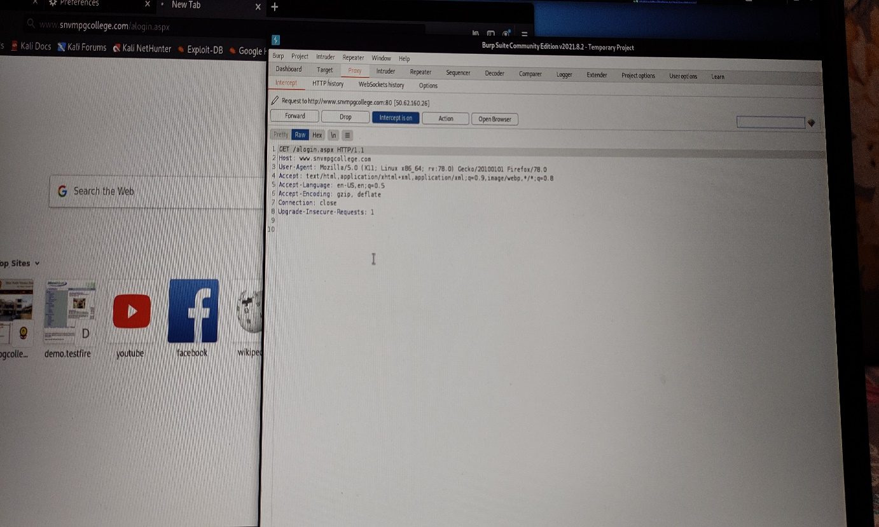

Step 3- Then try to login using any username and password on website open on your browser, the request access will send on Burp Suite

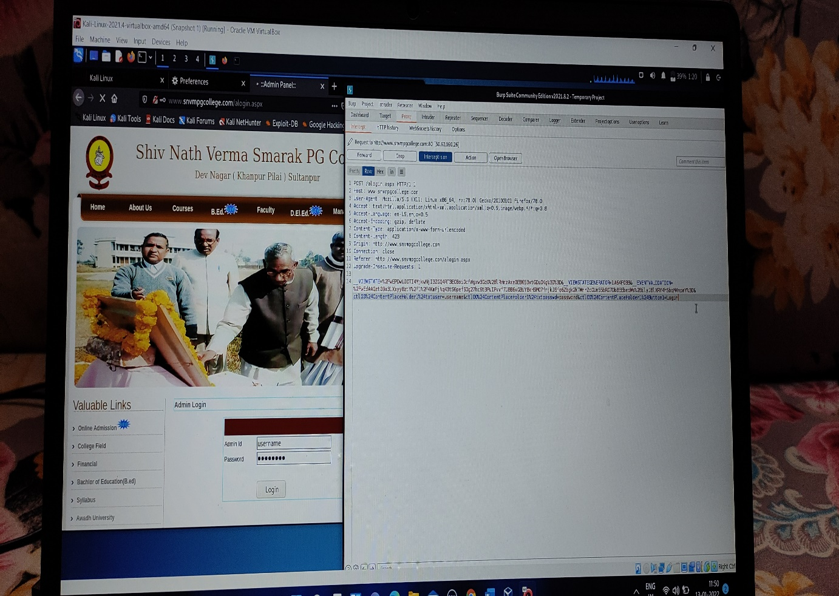

Step 4- Then click on **Action** a drop-down menu appears. Then in that drop down menu click **Send to Intruder**

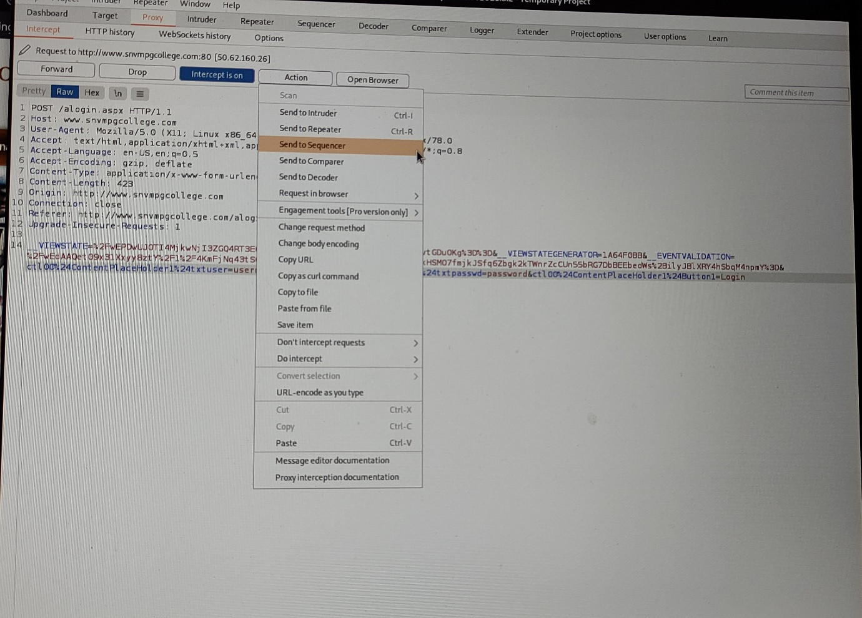

Step 5- Then click on **Intruder** tab and Click on **Position**. Then on right hand side click on **Clear$** to clear the marked position where to insert the payload.

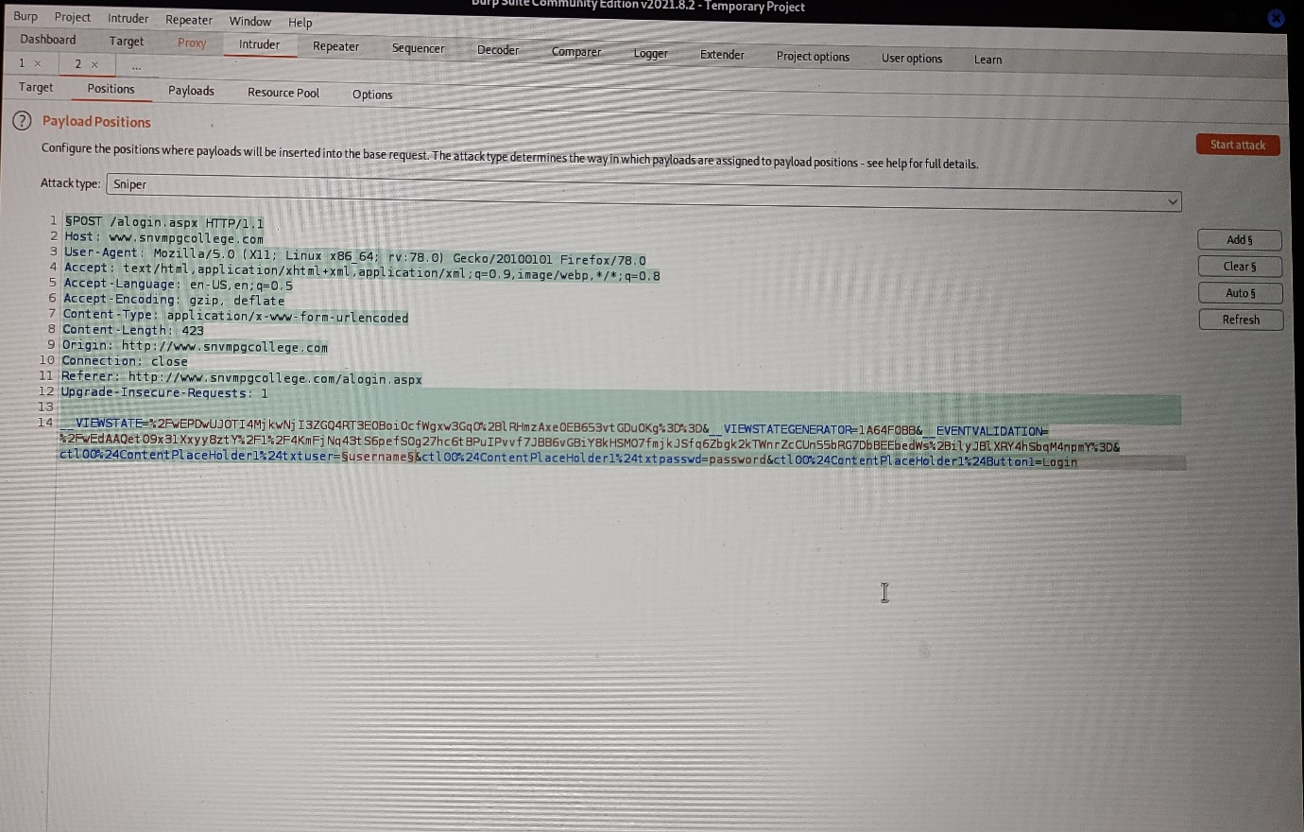

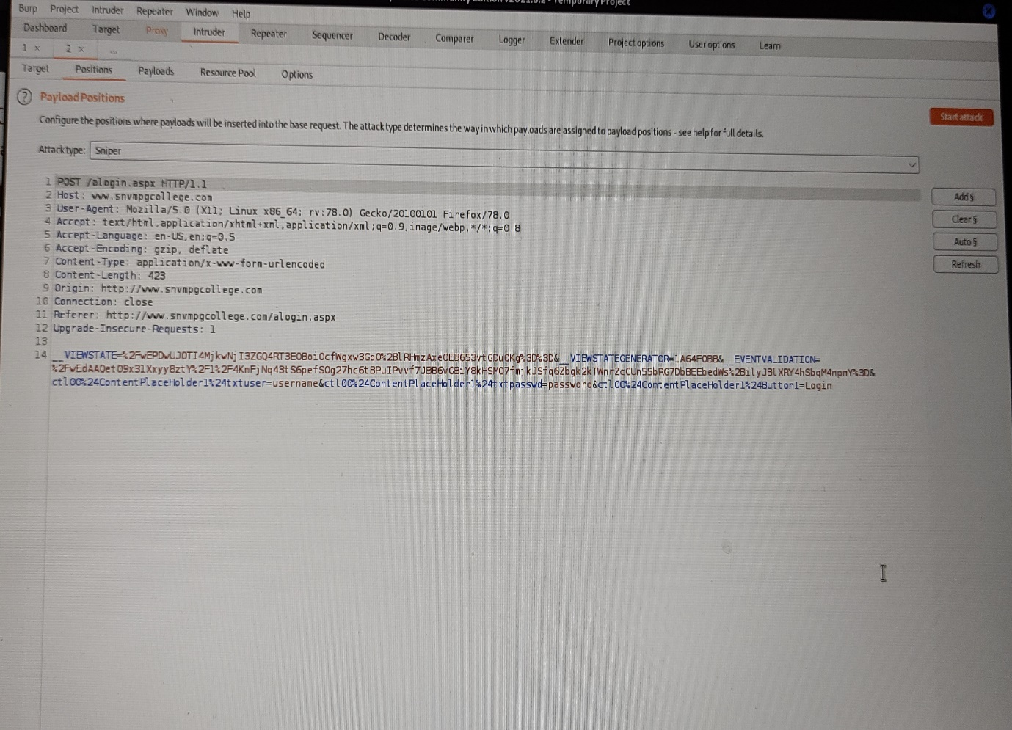

Step 6- Then by clicking on Add$ which is present on right hand side to add username and password to payload position.

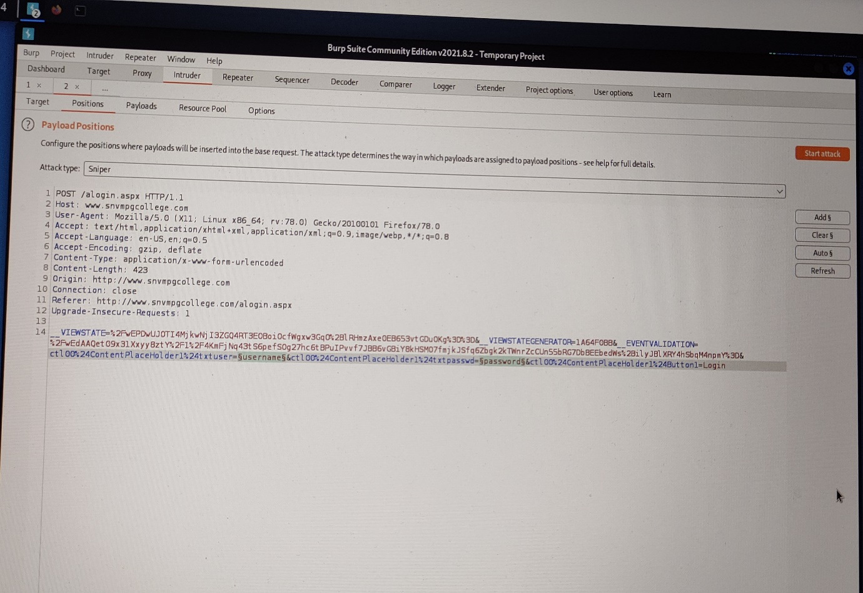

Step7- Then click on **Payloads** and then in **Payload Options** click on **load** and add the payloads. Here the payloads can be downloaded from google (GitHub).

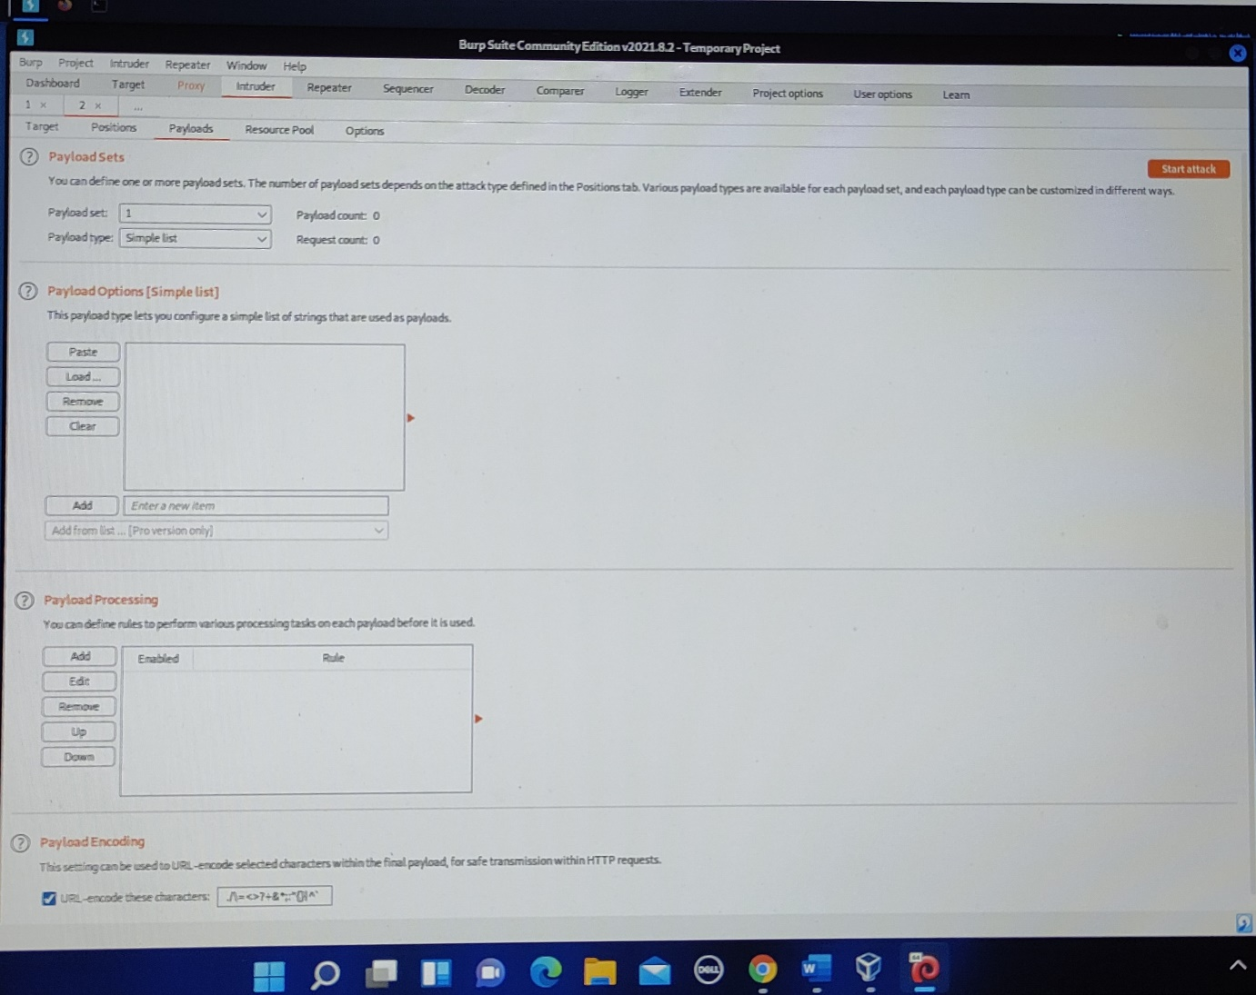

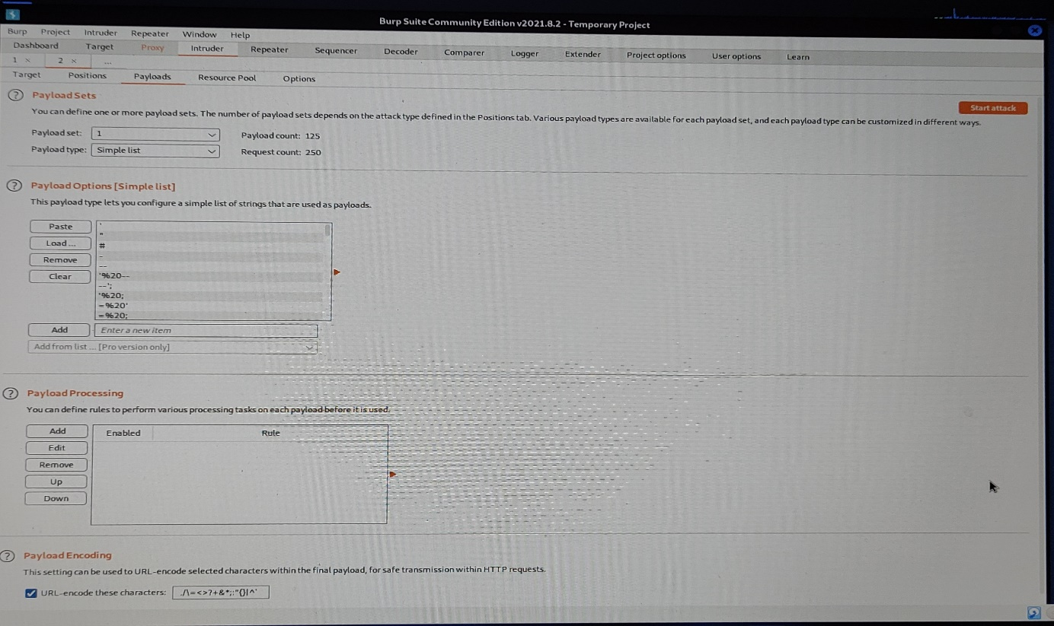

**Payload Added**

Step 8- Click on the **Start Attack.** The attack page gets opened as below.

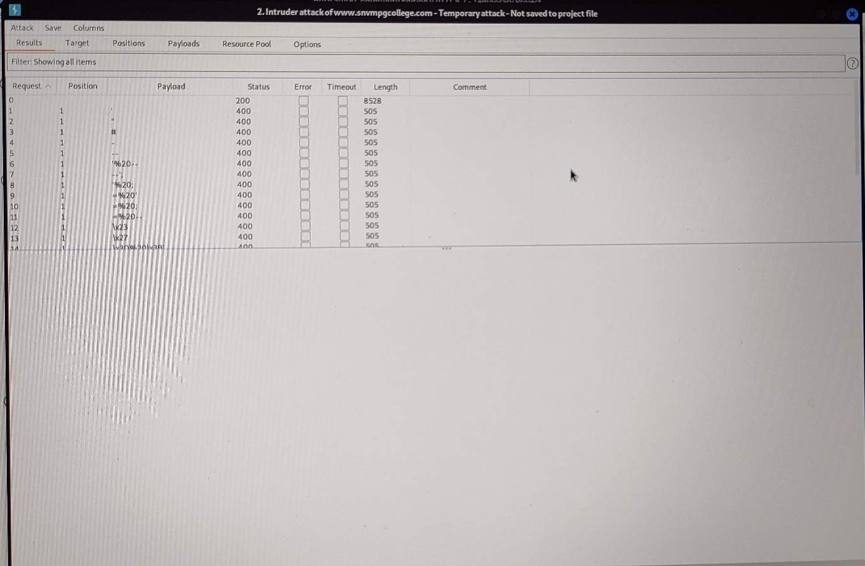

Step 8- Then click and check every payload that each one has given the **Bypass** to the login page.

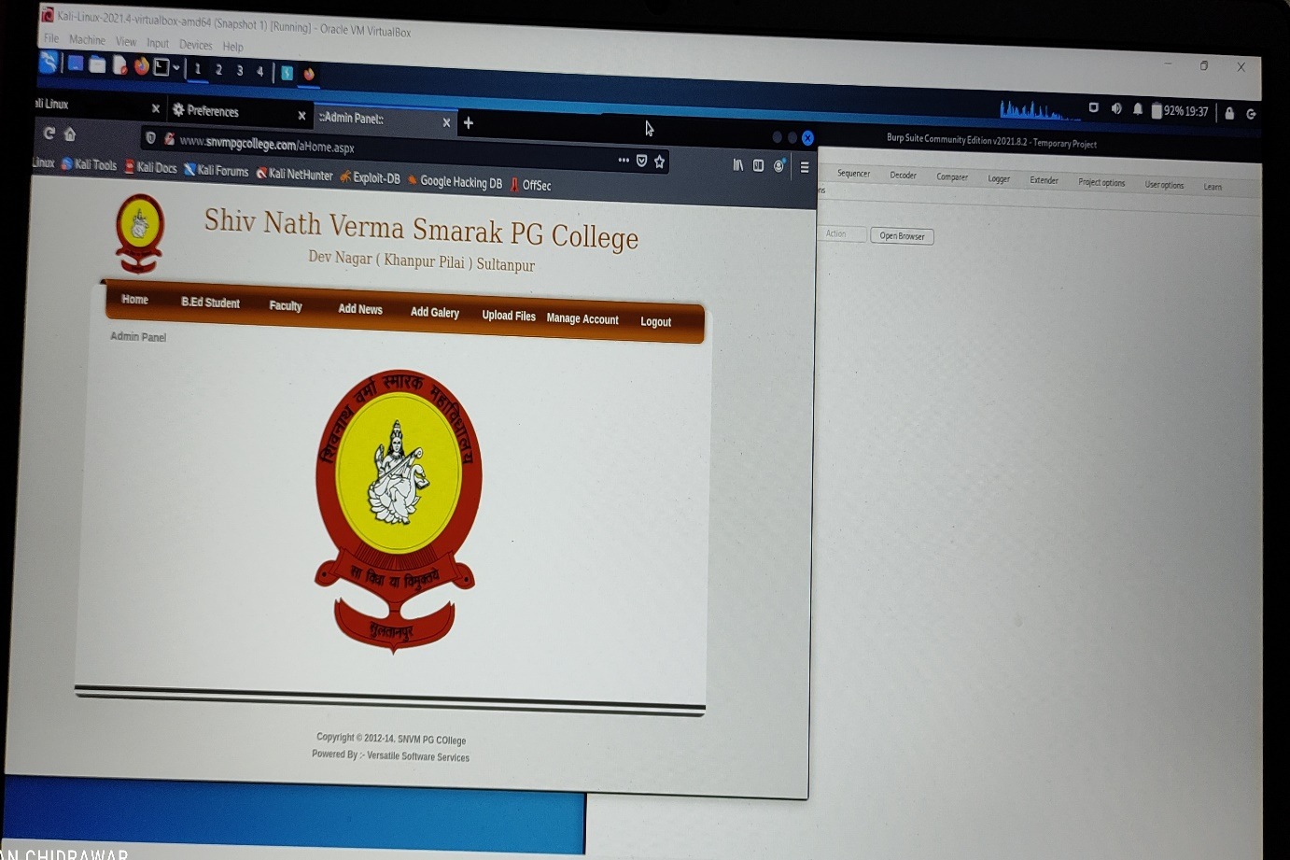

Successfully login to website...

Task 2: - Showing some live Cameras using Google Database:

By using Google Dorks (Exploit DB), try to find out some website(dorks) for live camera available in public.

Some Dorks used are: -

1. [intitle:"webcamXP" inurl:8080](https://www.exploit-db.com/ghdb/7697)
2. intitle:” live view /-axis “
3. live view – axis 210
4. inurl:” view/index.shtml”
5. intitle: axis camera l

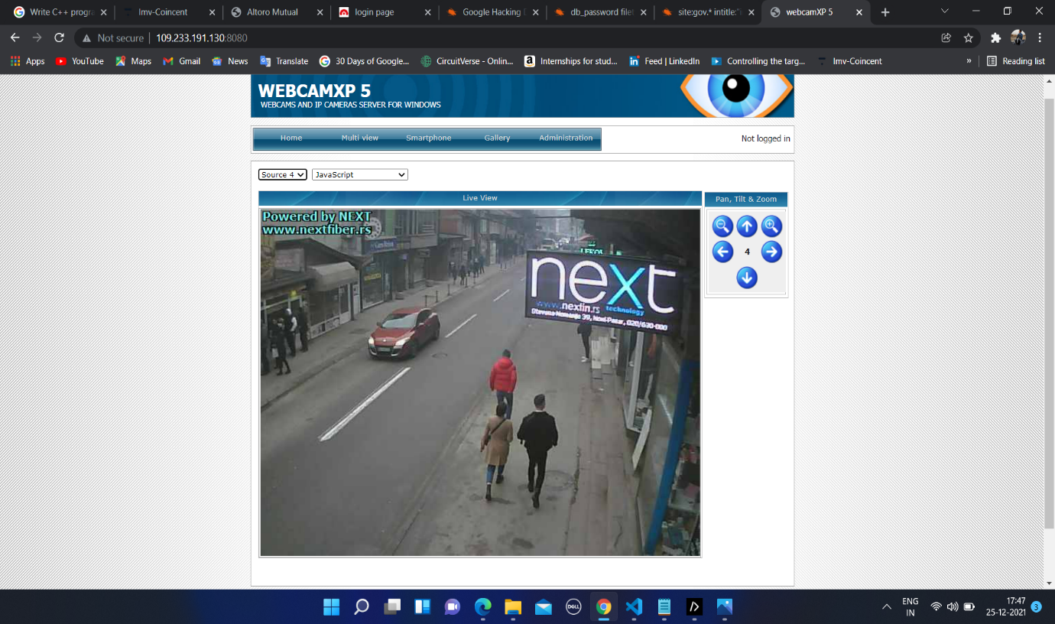

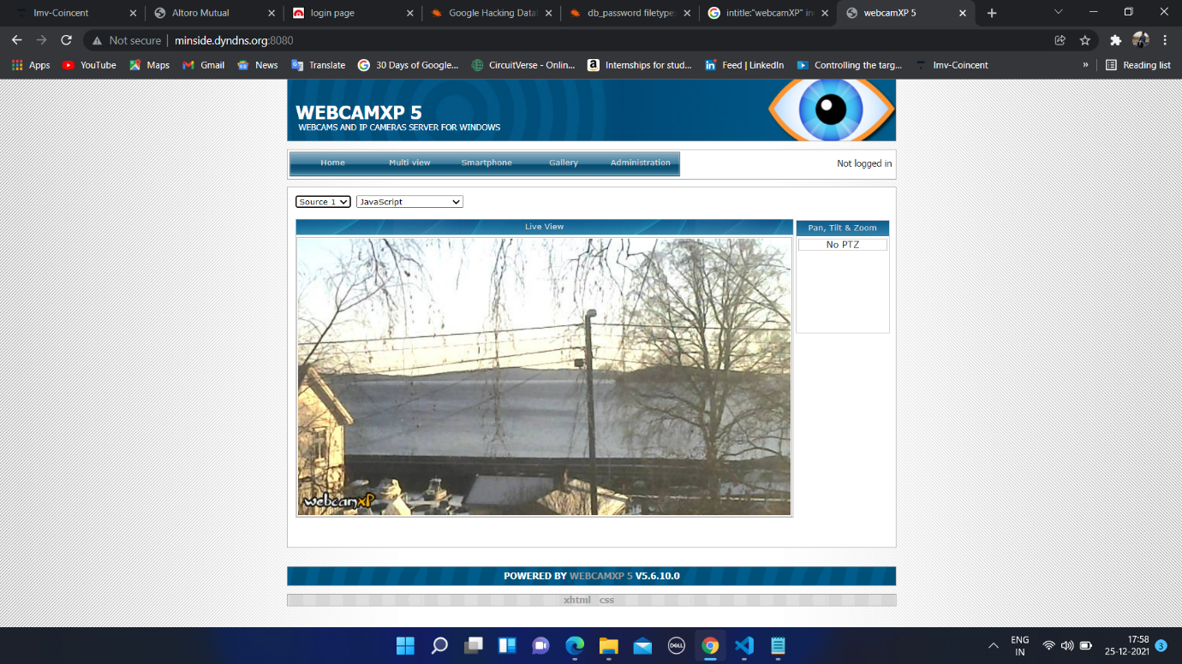

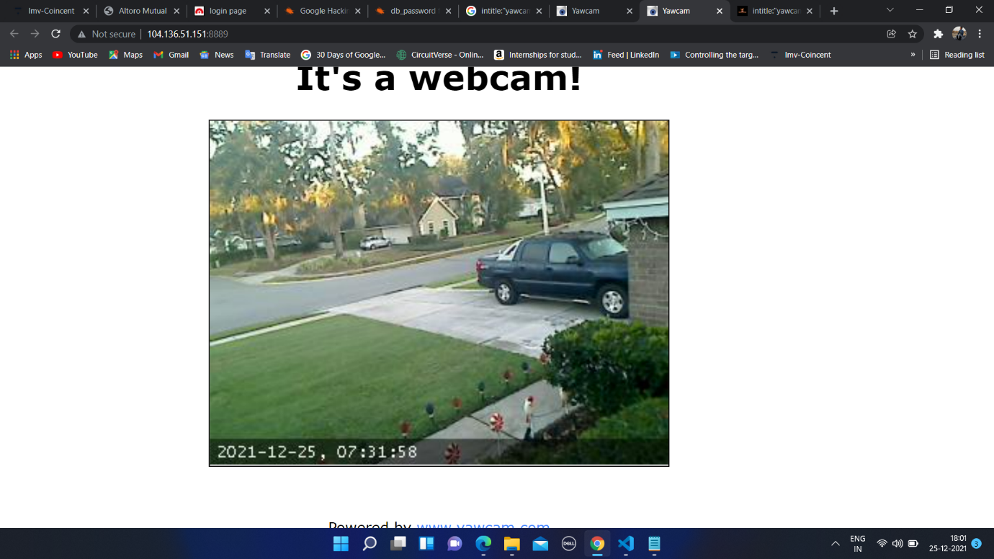

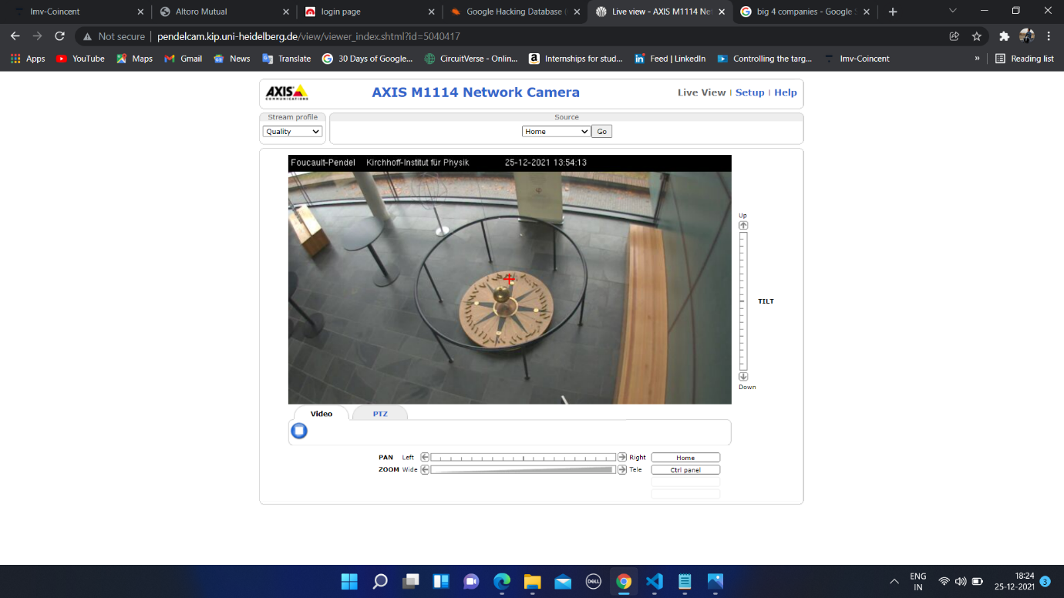

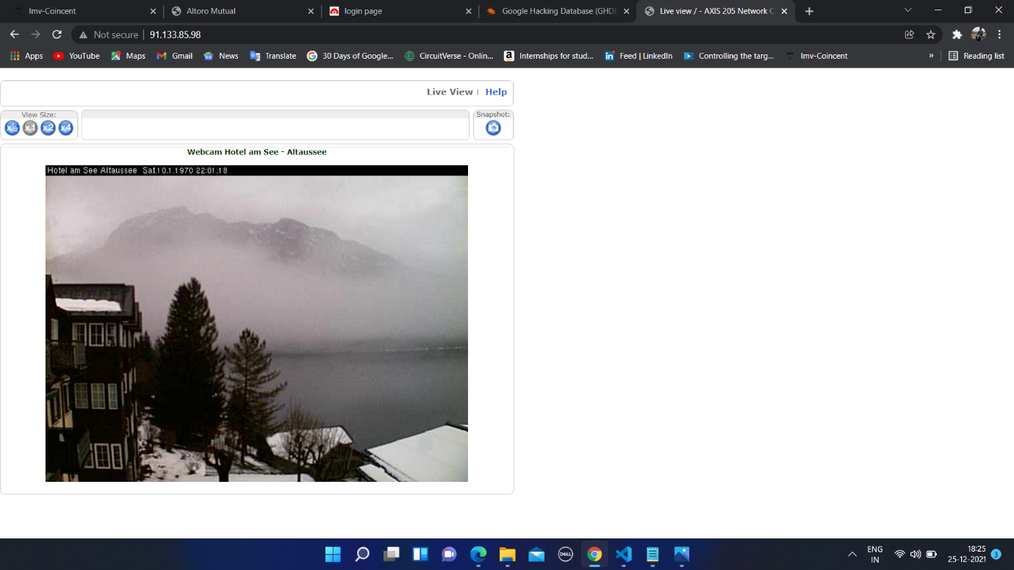

Done by: - Sohan Sudhir Chidrawar

**Done by: - Sohan Sudhir Chidrawar**